|  |  |  |  |  |  |  |
| --- | --- | --- | --- | --- | --- | --- |
| **Case Processing Summary** | | | | | | |
|  | Cases | | | | | |
| Valid | | Missing | | Total | |
| N | Percent | N | Percent | N | Percent |
| Pree Test | 33 | 100.0% | 0 | 0.0% | 33 | 100.0% |
| Post Test | 33 | 100.0% | 0 | 0.0% | 33 | 100.0% |

|  |  |  |  |  |
| --- | --- | --- | --- | --- |
| **Descriptives** | | | | |
|  | | | Statistic | Std. Error |
| Pree Test | Mean | | 84.5758 | .56580 |
| 95% Confidence Interval for Mean | Lower Bound | 83.4233 |  |
| Upper Bound | 85.7283 |  |
| 5% Trimmed Mean | | 84.6061 |  |
| Median | | 85.0000 |  |
| Variance | | 10.564 |  |
| Std. Deviation | | 3.25029 |  |
| Minimum | | 78.00 |  |
| Maximum | | 91.00 |  |
| Range | | 13.00 |  |
| Interquartile Range | | 6.00 |  |
| Skewness | | -.112 | .409 |
| Kurtosis | | -.892 | .798 |
| Post Test | Mean | | 88.3636 | .50155 |
| 95% Confidence Interval for Mean | Lower Bound | 87.3420 |  |
| Upper Bound | 89.3853 |  |
| 5% Trimmed Mean | | 88.3704 |  |
| Median | | 89.0000 |  |
| Variance | | 8.301 |  |
| Std. Deviation | | 2.88117 |  |
| Minimum | | 83.00 |  |
| Maximum | | 94.00 |  |
| Range | | 11.00 |  |
| Interquartile Range | | 4.50 |  |
| Skewness | | -.180 | .409 |
| Kurtosis | | -.680 | .798 |

|  |  |  |  |  |  |  |
| --- | --- | --- | --- | --- | --- | --- |
| **Tests of Normality** | | | | | | |
|  | Kolmogorov-Smirnova | | | Shapiro-Wilk | | |
| Statistic | df | Sig. | Statistic | df | Sig. |
| Pree Test | .127 | 33 | .196 | .957 | 33 | .219 |
| Post Test | .133 | 33 | .148 | .971 | 33 | .500 |
| a. Lilliefors Significance Correction | | | | | | |

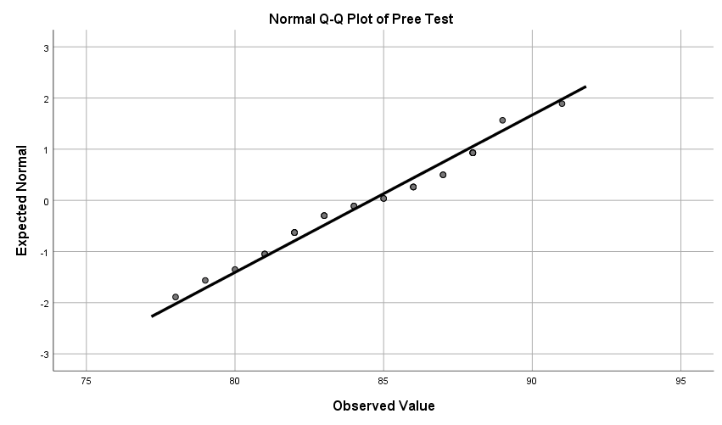

|  |  |  |  |  |  |
| --- | --- | --- | --- | --- | --- |
| **Paired Samples Statistics** | | | | | |
|  | | Mean | N | Std. Deviation | Std. Error Mean |
| Pair 1 | Pree Test | 84.5758 | 33 | 3.25029 | .56580 |
| Post Test | 88.3636 | 33 | 2.88117 | .50155 |

|  |  |  |  |  |
| --- | --- | --- | --- | --- |
| **Paired Samples Correlations** | | | | |
|  | | N | Correlation | Sig. |
| Pair 1 | Pree Test & Post Test | 33 | .948 | .000 |

|  |  |  |  |  |  |  |  |  |  |  |
| --- | --- | --- | --- | --- | --- | --- | --- | --- | --- | --- |
| **Paired Samples Test** | | | | | | | | | | |
|  | | Paired Differences | | | | | t | df | Sig. (2-tailed) | |
| Mean | Std. Deviation | Std. Error Mean | 95% Confidence Interval of the Difference | |
| Lower | Upper |
| Pair 1 | Pree Test - Post Test | -3.78788 | 1.05349 | .18339 | -4.16143 | -3.41433 | -20.655 | 32 | .000 |