Aristo Journal (Social, Politic, Humanities)

Social and Political Science Faculty, University of Muhammadiyah Ponorogo.  **1** p-ISSN 2338-5162 / e-ISSN

Trends and Challenges of Digital Transformation in the Public Sector: Policy Implications for Improving Public Services in Indonesia

ARTICLE INFO ABSTRAC

ARTICLE INFO

|  |  |
| --- | --- |
| **Article history**  Submited  Revised  Accepted  **Article History**  Send  Review Accepted | This research explores trends, challenges and innovations in digital transformation in the public sector, with a focus on its implications in Indonesia. The objectives of this study are to evaluate operational efficiency improvements in public services generated by digital transformation, identify challenges in the implementation of digital technologies, and provide policy recommendations to ensure the sustainability of technology adoption in the Indonesian public sector. The methodology used included a literature review and data analysis from the Scopus database, which was analyzed using VOSviewer to identify key patterns and trends in digital technology adoption in the public sector. The results show that the success of digital transformation depends not only on the adoption of new technologies, but also requires structural changes and organizational culture. Key challenges include resistance to change, the digital divide between urban and rural areas, and infrastructure limitations. This research provides policy recommendations that can accelerate the adoption of digital technologies in Indonesia, particularly through cross-sector collaboration and infrastructure improvements. The findings are expected to serve as a reference for policymakers and practitioners to strengthen the digitalization of public services in a sustainable manner. |
| **Keywords**  Digital Transformation  Public Sector  Public Policy  Digital Divide  Technology Infrastructure | This is an open access article under the [CC-BY-NC-SA](http://creativecommons.org/licenses/by-sa/4.0/) license.  Open access article with [CC-BY-NC-SA](http://creativecommons.org/licenses/by-sa/4.0/) model as the license. |

# Introduction

The Digital transformation in the public sector has been a major focus in academic literature over the past decades, given its significant impact on institutional sustainability and public service delivery (Mergel et al., 2019). This research explores trends and innovations in digital transformation, which are essential for governments to remain relevant in the face of rapid technological developments (Deloitte Insights, 2021; Huaytan et al., 2024). While there has been much progress in the adoption of digital technologies, such as e-government and the use of information and communication technologies (ICT) (Correa-Ospina et al., 2021). There are still significant knowledge gaps in understanding how this transformation can be effectively implemented across different geographical and cultural contexts(Bajraliu & Qorraj, 2023). For example, while the implementation of GovTech has helped improve transparency and accountability, there are still major challenges in terms of technological infrastructure and resistance to change, especially in remote areas and among older generations (Hietala et al., 2023; Iyer & Kuriakose, 2024). This research identifies areas where existing knowledge is limited, such as understanding the long-term impact of digital technology adoption in public governance, as well as how policies can be designed to address the digital divide between urban and rural areas. These gaps are critical to fill in order for digital transformation to become not only a trend but also a sustainable solution in improving the effectiveness and efficiency of public services (Galushi & Malatji, 2022)

A key issue faced in digital transformation in the public sector is the complexity of system integration and interoperability which often complicates successful implementation (Irani et al., 2023). In addition, resistance to change is not always an inhibiting factor, but rather a deeper issue related to policies and governance that support the digitization process (Tangi et al., 2021; László et al., 2024). For example, in the Indonesian context, despite initiatives such as Sistem Pemerintahan Berbasis Elektronik (SPBE), its implementation is still hampered by infrastructure limitations and lack of digital skills among civil servants (Dečman et al., 2022; Hien et al., 2024). The urgency of this research lies in the pressing need to address these challenges to ensure that digital transformation not only improves operational efficiency but also encourages citizen participation in governance and reduces opportunities for corruption (Agbozo & Asamoah, 2019). As such, this research focuses on devising policy strategies that can be adopted by the government to accelerate digital transformation, particularly by strengthening collaboration between the public and private sectors, as well as enhancing digital skills at all levels of society (Pislaru et al., 2024). This research is important to provide policymakers with the necessary insights to design policies that can ensure the sustainability of digital transformation, so that it can have a significant positive impact on society at large.

# Method

This research uses a systematic literature review method approach to explore trends, challenges and innovations in digital transformation in the public sector, with a focus on the Indonesian context(Wirtz et al., 2019). The data used was sourced from English-language scholarly articles retrieved from the Scopus database, published between 2016 and 2023. The selected articles focused on the topics of digital transformation, e-government, technological innovation, and public policy in the public sector. From a total of 460 identified articles, 135 articles were filtered based on topic relevance and analyzed in depth. The data search process was conducted using keywords such as "digital transformation," "public sector," and "e-government," and involved a rigorous selection to ensure the articles fit the research topic.

Data were analyzed using thematic analysis. Each article was read to identify key themes, such as technology adoption challenges, infrastructure limitations, resistance to change, and public service innovation. The coding results were organized into thematic categories to make it easier to understand the patterns that emerged from the literature. In addition, this study used VOSviewer to visualize the relationships between the various themes that emerged from the literature. The use of VOSviewer makes it easier to understand dominant research trends as well as areas that still require further exploration, such as the digital divide in Indonesia and the challenges of technology adoption in remote areas.

This research also emphasizes the importance of validity through data triangulation. The results of the analysis were compared with other literature to ensure consistency of findings, and expert discussions were held with digital transformation experts to ensure the relevance of the research results to the local Indonesian context. Although this study uses secondary data, the findings still provide important insights into digital transformation trends and policies in the Indonesian public sector. However, the limitation of this study lies in the absence of primary data, so further research involving stakeholder interviews or surveys is recommended to complement the results.

# Literature Review

***Application of Technology in Digital Transformation in the Public Sector***

Digital transformation in the public sector has created various technological innovations designed to improve the efficiency and quality of public services. Cloud computing allows for more efficient data storage and management, as well as reduced operational costs(Deloitte Insights, 2021). In addition, big data analytics helps governments make data-driven decisions, enabling more accurate and effective policy planning(Gangneux & Joss, 2022). Artificial intelligence (AI) is also being used to automate administrative processes, such as the use of chatbots to improve citizen interactions with government(Mergel et al., 2023)

Although technologies such as AI and IoT offer many benefits, their implementation in Indonesia is still hampered by infrastructure gaps, especially in remote areas(Ibáñez-Jiménez & Palomo-Zurdo, 2024). The Internet of Things (IoT) enables real-time monitoring of infrastructure, but its implementation is often hampered by limited internet connectivity(Latupeirissa et al., 2024). In the Indonesian context, literature focusing on the impact of IoT implementation in the public sector is still limited, indicating the need for more locally relevant studies(Palos-Sánchez et al., 2023)

***Organizational Transformation and Challenges in the Digital Age***

The success of digital transformation in the public sector depends not only on technology adoption, but also on structural adjustments and organizational culture(Vinarski-Peretz & Kidron, 2024). Digital skills development is essential to ensure public servants are able to utilize new technologies effectively(Debeljak & Dečman, 2022). However, in Indonesia, digital skills training is still uneven, especially in more remote areas, leading to a technology adoption gap between central and local governments(Bahl et al., 2023). Agile methodologies can help government organizations respond more quickly to change, although adoption is still limited due to rigid bureaucracy(Bunduchi et al., 2020)

Resistance to change is a major challenge in digital transformation, especially in developing countries such as Indonesia, where understanding of the long-term benefits of digitalization is still minimal(Kemal & Shah, 2023). This is exacerbated by infrastructure limitations and mindsets that are not ready to adopt change widely(Werner & Lehan, 2023). Therefore, policies that support organizational change and intensive training are necessary to overcome these obstacles(Mariani & Bianchi, 2023)

***Innovation in Government Digital Service Delivery***

Innovations in digital service delivery by the government have facilitated interactions between citizens and the government. Digital portals and mobile applications allow citizens to access government services directly without having to visit government offices(Kristiyanto, 2016). Chatbots are also being used to provide more responsive and personalized public services, reducing citizens' waiting time for information(Daub et al., 2020)

However, the digital divide between urban and rural areas in Indonesia is still a major barrier to the equitable deployment of digital services(Onyango & Ondiek, 2023). Meanwhile, some major cities in Indonesia have begun to implement smart city concepts that utilize IoT and data analytics to manage infrastructure in real-time, although implementation is still in its early stages(Devlin & Coaffee, 2023). Digital collaboration between government departments has also begun to be adopted, enabling knowledge sharing through cloud-based platforms and virtual workspaces, which facilitates coordination between agencies(Girard, 2024)

# Results and Discussion

The uploaded documents inform several important aspects of digital transformation in the public sector. There are 460 relevant English-language journal documents, with 226 documents from social science fields that focus on the social aspects of digital transformation. 135 of these documents are open access, making them more widely accessible to support inclusive research(Huo et al., 2022)

From the search results of the Scopus database, based on the year of publication, it shows a significant trend in the development of publications related to this topic(Lawelai & Nurmandi, 2024). The line diagram sourced from Scopus shows an increasing trend in the number of documents related to digital transformation in the public sector from 2016 to 2023. In 2016 and 2017, there were only 2 documents published each year, reflecting the low interest in this topic. The number of documents increased slowly to 3 in 2018 and jumped to 10 documents in 2019 and 2020, indicating a growing interest in public sector digitization. In 2021, the number of publications rose significantly to 23 documents, followed by 28 documents in 2022. The peak came in 2023, with 54 documents published, reflecting a huge surge in interest in digital transformation, especially in the last three years. This increase reflects the growing importance of digitization in public services and the adoption of new technologies in the sector(Lawelai, 2023).

Documents by Year (2016-2023)

Over the past decade, research on digital transformation in the public sector has grown rapidly, conducted by researchers from various countries with varying levels of quality. This has led them to publish their findings in leading Scopus-indexed journals.

Figure 2. Documents by Country

The bar chart above shows the number of publications related to digital transformation in the public sector sourced from Scopus, by country. Italy has the highest number of publications with 10 documents, followed by Brazil with 8 documents. Some other countries such as Portugal, Russia, Finland and the United States have 7 documents each. Countries such as Germany and the Netherlands have 6 documents, while Croatia and Belgium have 5 documents each. This diagram illustrates the geographical distribution of research on this topic, with Italy being the largest contributor.

Figure 3. Documents by scientific field

The diagram above illustrates the distribution of the number of publications from various scientific journals listed on Scopus related to the field of digital transformation in the public sector. The journal "Government Information Quarterly" emerges as the most dominant source with 8 publications, making it a major contribution to the literature on this topic. "Digital Government Research and Practice" follows with 4 publications. Other journals such as "Ejournal Of Edemocracy And Open Government", "International Journal Of Information Management", "Public Policy And Administration", and "Transforming Government People Process And Policy" contributed 3 publications each(Borgogno & Colangelo, 2019). Meanwhile, "Administratie Si Management Public", "Big Data And Society", and "Central European Public Administration Review" each recorded 2 publications. Overall, this diagram shows that "Government Information Quarterly" is the most significant source for studies related to digital transformation in the public sector.

Figure 4. Documents by Author

The diagram displays the number of publications from various authors whose data is sourced from Scopus, related to a specific topic. Dečman, M., Mergel, I., and Tangi, L. are the main contributors, each with 3 publications, while other authors such as Peruccchi, V., Omar, A., Myeong, S., Jambari, D.I., Dominic, P.D.D., Brandão, J.L.A., and Androniceanu, A. have 2 publications each. Overall, this diagram shows that the contributions to the literature in Scopus on the topics covered are fairly evenly distributed, with Dečman, M., Mergel, I., and Tangi, L. being the most prolific authors.

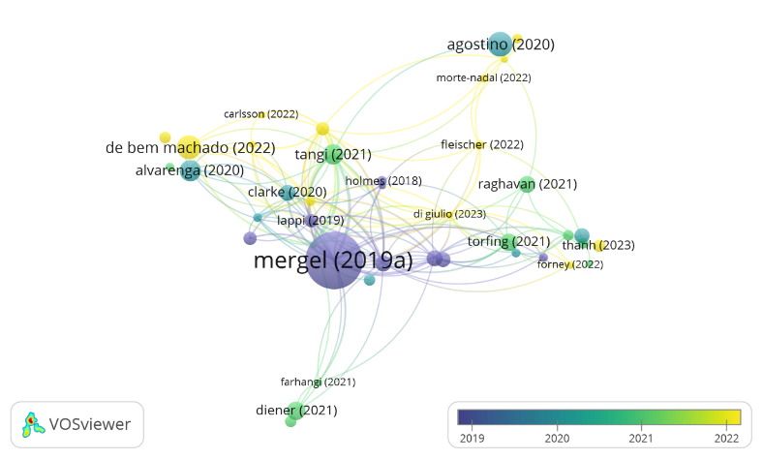

Article Network Map Based on Linkage and Frequency of Occurrence

The illustration shows a network map showing the interconnections between scientific articles based on the frequency of co-occurrence or author collaboration, with data sourced from Scopus. The largest node, "Mergel (2019a)", is the center of the network, indicating that the article is frequently cited or referenced in many related studies. The color and size of the nodes and their connecting lines reflect the temporal distribution of publications from 2019 to 2022, showing the influence and temporal relationship between articles. Other articles such as "Agostino (2020)", "Tangi (2021)", and "de Bem Machado (2022)" also contribute to this network, but with less frequency and influence. Overall, this map illustrates the interactions and knowledge networks formed between the articles in the topic.

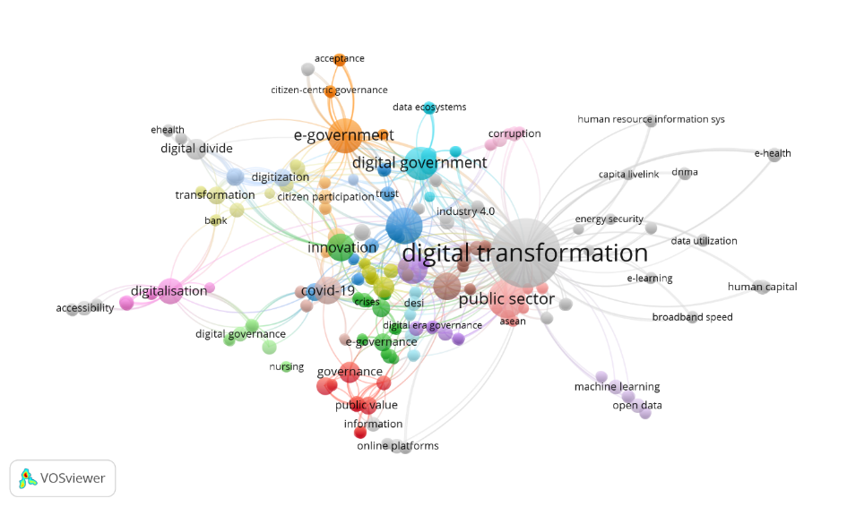

Figure 5. Authors Keyword Co-Accuration Network Map

The figure displays a network map visualization created using VOSviewer, showing the interrelationships between keywords frequently used in publications related to "digital transformation" and other topics such as "e-government," "public sector," "innovation," and "covid-19" (Farhan HR & Nurmandi, 2022). Each circle (node) represents a keyword, with the size reflecting its frequency of occurrence, while the color indicates clusters of keywords that frequently co-occur. The connecting lines between the nodes show the co-occurrence relationship between the keywords, where the thicker the line, the more frequently the two keywords co-occur in the publications. Overall, this visualization illustrates the structure and focus of research in the field of digital transformation as well as the relationship between various relevant topics.

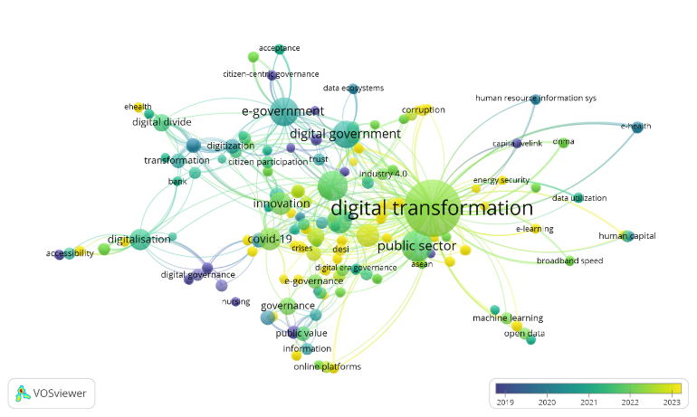

Network Map Visualization of co-occurrence author keyword overlay

The figure displays an author keyword co-occurrence overlay visualization illustrating the relationship between frequently co-occurring keywords in scholarly publications related to "digital transformation" and other related topics, with an added time dimension showing the development of research trends over the years (Brochado et al., 2024). The color of the nodes (circles) represents the year in which the keyword was most used, with a color gradient from blue (2019) to yellow (2023), showing how the research focus has evolved over time. For example, keywords related to "covid-19" tend to appear in yellow, indicating that this is a relatively new topic, whereas older keywords such as "digital governance" and "e-government" are darker in color, indicating their popularity in previous years(Aseeva, 2024). The fixed connecting lines show the co-occurrence relationship between the keywords, giving an idea of how these concepts are related to each other in a dynamic time context.

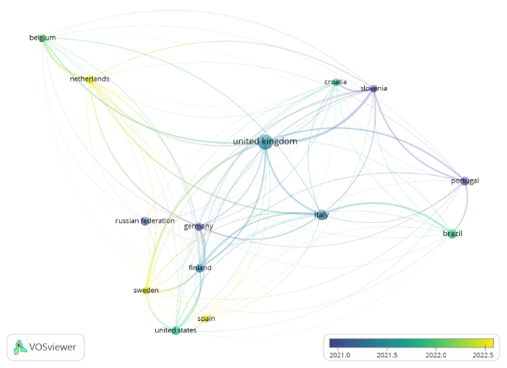

Figure 7: Network Map of Relationships between countries

This figure is a network visualization from VOSviewer that shows the relationship between countries based on collaboration or influence in a context, with additional time information displayed through a color scale from 2021 to 2022.5. Each dot represents a country, and the connecting lines are colored according to the period of collaboration, where blue indicates earlier collaboration and yellow indicates more recent collaboration. The United Kingdom is at the center of the network, signifying a central role in collaboration with many countries such as Croatia, Slovenia, and Italy. Countries such as Belgium and the Netherlands have strong relationships and vary in the period of collaboration, while Germany shows cross-country relationships with the Russian Federation, the United States, and Sweden. This visualization illustrates the global interactions between countries and the development of their collaboration over the analyzed time span.

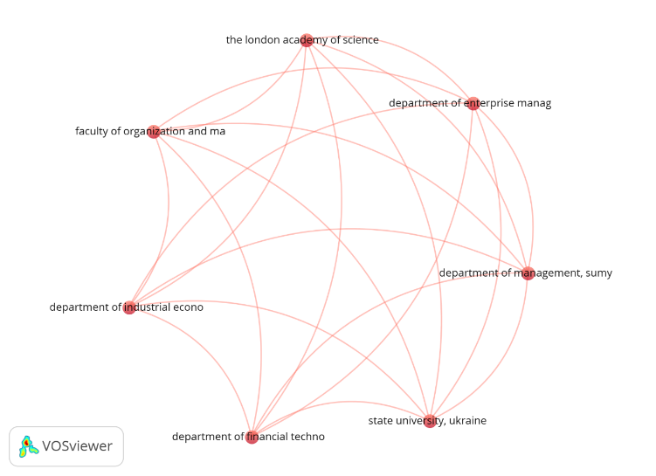

Network Map Network Visualization co-authorship organization

This visualization depicts a network of cooperation between organizations based on co-authorship in scientific publications, where each node represents an institution, such as "the London Academy of Science" or "state university, Ukraine," and the connecting lines between nodes indicate collaboration in the writing of scientific articles. The size of the nodes indicates the frequency of an organization's involvement in co-authorship, while the thickness of the lines indicates the strength or intensity of collaboration between those organizations. This visualization helps understand patterns of scientific collaboration, identify key actors in research networks, and see how knowledge and resources are transferred between institutions.

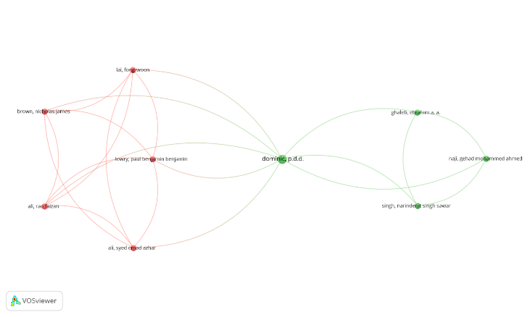

Figure 8. Network Map Overlay Visualization of co-authorship authors

The co-authorship overlay visualization shows the collaboration relationship between authors in a scientific publication network, where each node represents an author and the edges indicate the frequency of collaboration. Larger nodes reflect authors with larger contributions, and thicker lines indicate more frequent collaboration. The colors of the nodes and lines form clusters that reflect groups of authors who frequently collaborate, with red and green representing the two main groups. Authors like *dominic, p.d.d.* act as a link between the two clusters, signaling cross-group collaboration. This visualization helps identify collaboration groups and key authors that connect scientific communities.

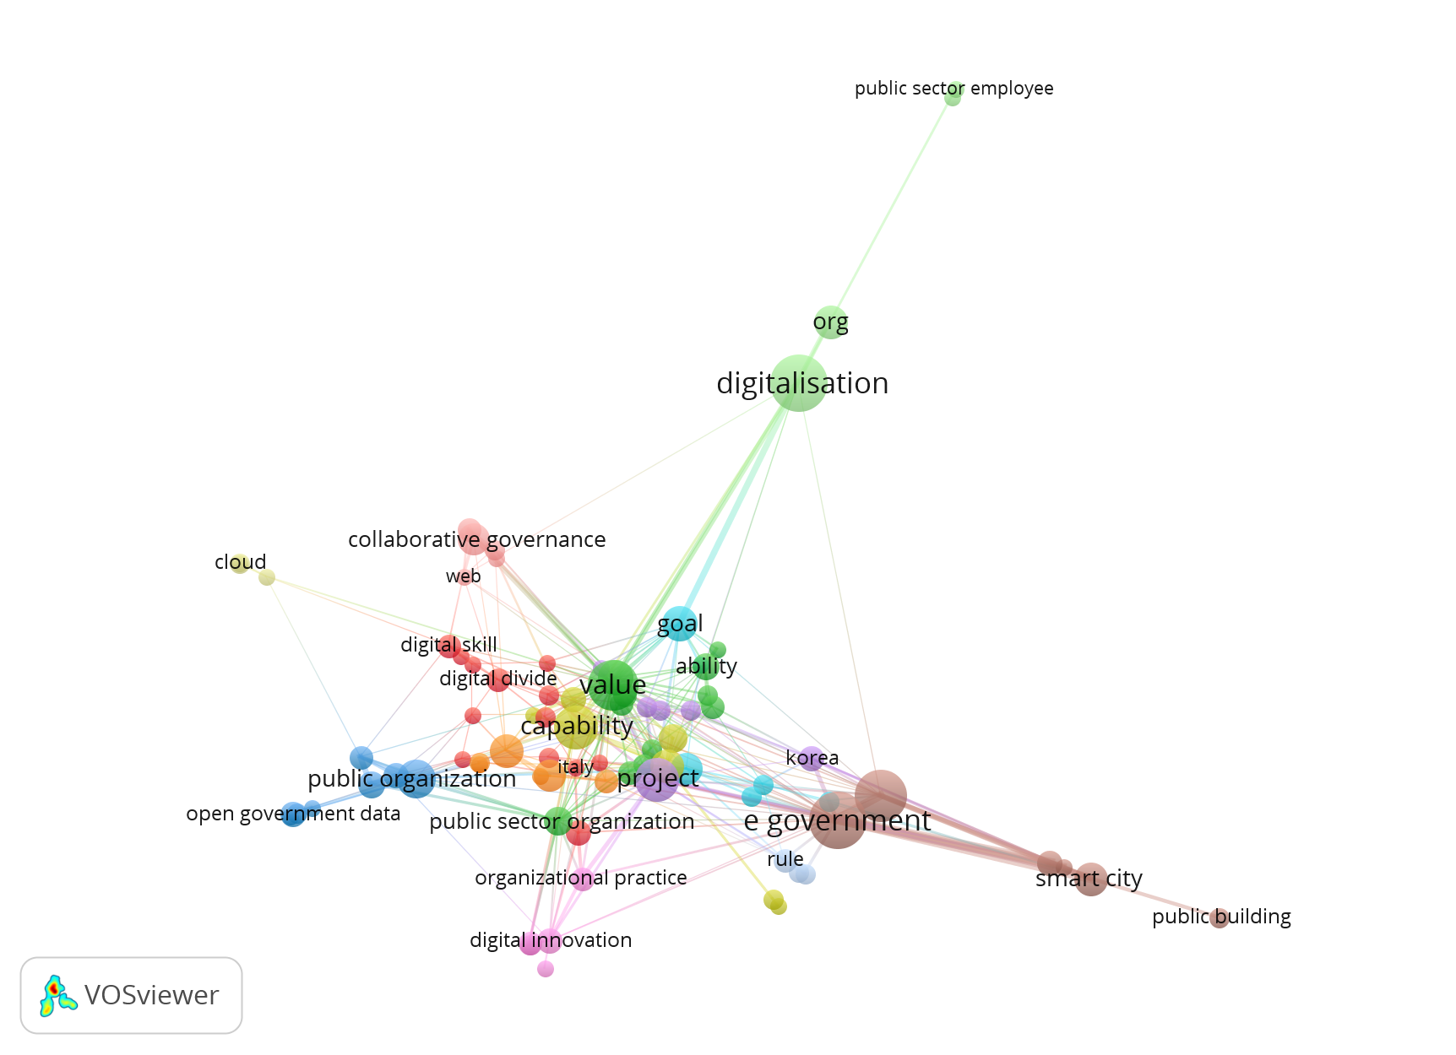

Network Visualization Network Map

The figure shows a network visualization illustrating the relationships between keywords or concepts related to digital transformation in the public sector, such as "digitalization," "e-government," and "smart city(Pislaru et al., 2024). Different circles (nodes) represent these terms, with the size of the circle indicating the frequency or importance of the term. The edges show the relationships between terms, where thicker lines indicate stronger relationships. Different colors in groups of circles indicate clusters or groups of closely related terms. This visualization helps in identifying key themes and trends in the context of digital transformation, with larger and more prominent terms indicating key concepts that are frequently discussed. This visualization was created using "VOSviewer" software commonly used for bibliometric analysis.

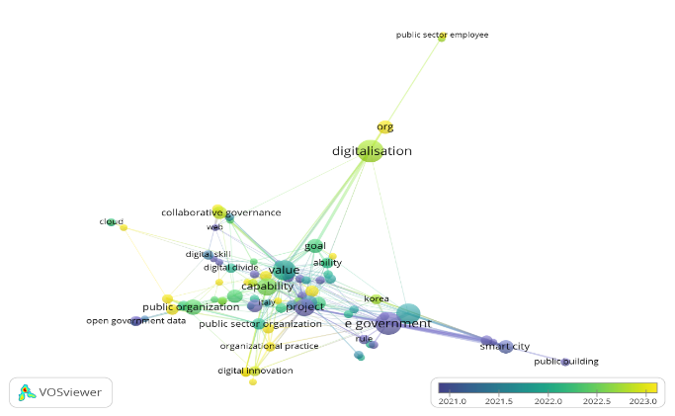

Figure 9. Network Map Overlay Visualization

The Overlay Visualization Network Map in the figure shows the relationships between keywords related to digital transformation in the public sector, with colors representing changes in the relevance or occurrence of these concepts over time, as indicated by the color scale at the bottom of the figure. Large circles indicate concepts that are more important or frequently discussed, while lines connecting the circles show the interrelationships between concepts. The colors of the nodes and lines reflect changing trends, where yellow indicates newer concepts and blue for older ones, helping in understanding the evolution of the topic in recent years.

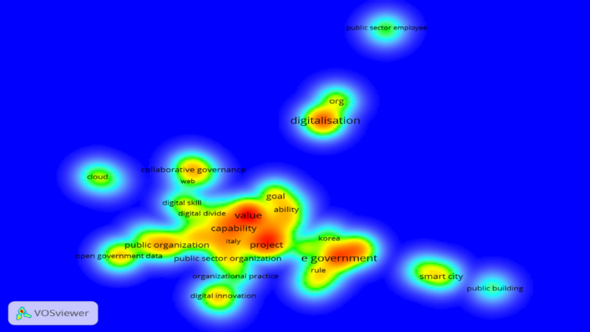

Figure 10. Density Visualization Network Map

The Density Visualization Network Map in the figure shows the density of distribution of keywords or concepts related to digital transformation in the public sector. The colors on the map reflect the density or frequency of occurrence of terms in the network, with red and yellow indicating areas of high density or frequently discussed terms, while green and blue indicate areas of lower density. Areas in red or yellow represent the center of attention or main topics of discussion, such as "digitalization," "e-government," and "public organization," which are the focus in the literature or data analyzed. This map helps identify key areas and sub-topics of importance in the context under study.

# Conclusion

This research presents a comprehensive overview of trends and innovations in digital transformation in the public sector, obtained through data analysis from Scopus and visualization using VOSviewer. The findings of this research confirm that digital transformation in the public sector is more than just the adoption of new technologies. The process includes comprehensive changes in organizational structure, business processes, work culture, as well as managerial capabilities to manage technological innovations.

Strong leadership, active engagement from all stakeholders, including the public, and the right policy support have proven to be critical success factors for digital transformation. In addition, flexible and innovation-oriented regulatory and policy support is needed to ensure successful technology adoption in various sectors. The success of digital transformation is also determined by organizational readiness in terms of adequate technological infrastructure and human resource competencies, especially digital skills among public sector employees.

From a global perspective, digital transformation in the public sector faces a number of challenges, such as technology infrastructure gaps, resistance to change among employees, and low levels of digital literacy. In Indonesia in particular, these challenges are compounded by the digital divide between urban and rural areas, which impacts the quality of public services in remote areas. Successful digital transformation in Indonesia will require significant efforts to improve access to digital technology, strengthen infrastructure, and ensure ongoing training for civil servants to adopt new technologies such as artificial intelligence (AI) and the Internet of Things (IoT).

In addition, digital transformation in Indonesia can be strengthened through increased collaboration between the public and private sectors, particularly in building more equitable digital infrastructure. The Indonesian government can leverage public-private partnerships to accelerate digitalization in remote areas and improve the quality of public services. Furthermore, the adoption of clear and measurable performance indicators, such as increased public digital access, decreased bureaucratic time, and number of employees trained in digital skills, will be helpful in monitoring and measuring the success of digital transformation initiatives.

The research also highlights the need for a holistic and collaborative approach to managing digital transformation, involving all stakeholders from government, the private sector and society at large. Digital skills development, investment in technology, and regulatory adjustments are key to the long-term success of this transformation.

Overall, this research makes a significant contribution to the literature on digital transformation in the public sector, with a focus on the challenges and opportunities faced by developing countries such as Indonesia. The findings not only provide practical insights for policy makers, but also for academics who want to understand more about the dynamics and development of digital transformation in the public sector. It is hoped that the strategies suggested in this research can guide the Indonesian government and other countries in designing and implementing sustainable and inclusive digital transformation policies.

# Acknowledgement

The author expresses his deep gratitude to the Jusuf Kalla School of Government, Universitas Muhammadiyah Yogyakarta, for the exceptional facilities provided during the internship. Thanks to the esteemed tutors whose invaluable guidance and unwavering support were instrumental in completing this manuscript.

**References**

Agbozo, E., & Asamoah, B. K. (2019). The role of e-government systems in ensuring government effectiveness and control of corruption. *R-Economy*, *5*(2), 53–60. https://doi.org/10.15826/recon.2019.5.2.006

Aseeva, A. (2024). Liable and Sustainable by Design: A Toolbox for a Regulatory Compliant and Sustainable Tech. *Sustainability (Switzerland)*, *16*(1). https://doi.org/10.3390/su16010228

Bahl, K., Kiran, R., & Sharma, A. (2023). Scaling Up Banking Performance for the Realisation of Specific Sustainable Development Goals: The Interplay of Digitalisation and Training in the Transformation Journey. *Sustainability (Switzerland)*, *15*(18). https://doi.org/10.3390/su151813798

Bajraliu, A., & Qorraj, G. (2023). Digital Transformation’S Impact on Sustainable Hr Management: Comparative Study of Work-Life Balance and Skill Development in Public Versus Private Sectors of a Developing Country. *Public Policy and Administration*, *22*(3), 358–369. https://doi.org/10.5755/j01.ppaa.22.3.35071

Borgogno, O., & Colangelo, G. (2019). Data sharing and interoperability: Fostering innovation and competition through APIs. *Computer Law and Security Review*, *35*(5), 105314. https://doi.org/10.1016/j.clsr.2019.03.008

Brochado, Â. F., Rocha, E. M., & Costa, D. (2024). A Modular IoT-Based Architecture for Logistics Service Performance Assessment and Real-Time Scheduling towards a Synchromodal Transport System. *Sustainability (Switzerland)*, *16*(2). https://doi.org/10.3390/su16020742

Bunduchi, R., Tursunbayeva, A., & Pagliari, C. (2020). Coping with institutional complexity: Intersecting logics and dissonant visions in a nation-wide healthcare IT implementation project. *Information Technology and People*, *33*(1), 311–339. https://doi.org/10.1108/ITP-08-2018-0373

Correa-Ospina, M., Saxena, D., & Pinzón, B. H. D. (2021). Mechanisms underpinning the usage of e-government services by businesses: A proposal based on previous empirical research. *EJournal of EDemocracy and Open Government*, *13*(2), 154–183. https://doi.org/10.29379/jedem.v13i2.685

Daub, M., Domeyer, A., de Lamaa, A., & Renz, F. (2020). Digital public services: How to achieve fast transformation at scale. *McKinsey Insights*, *July*, N.PAG-N.PAG.

Debeljak, A., & Dečman, M. (2022). Digital Transformation of Slovenian Urban Municipalities: A Quantitative Report on the Impact of Municipality Population Size on Digital Maturity. *NISPAcee Journal of Public Administration and Policy*, *15*(2), 25–51. https://doi.org/10.2478/nispa-2022-0012

Dečman, M., Stare, J., & Klun, M. (2022). The impact of the COVID-19 crisis on the development of the information society in Slovenia. *Administratie Si Management Public*, *2022*(39), 77–96. https://doi.org/10.24818/amp/2022.39-05

Deloitte Insights. (2021). *Seven pivots for government’s digital transformation*.

Devlin, C., & Coaffee, J. (2023). Planning and technological innovation: the governance challenges faced by English local authorities in adopting planning technologies. *International Journal of Urban Sciences*, *27*(S1), 149–163. https://doi.org/10.1080/12265934.2021.1997632

Farhan HR, M., & Nurmandi, A. (2022). *Government Data Processing Mechanism to Support Smart City: A Bibliometric Review BT - HCI International 2022 – Late Breaking Posters* (C. Stephanidis, M. Antona, S. Ntoa, & G. Salvendy (eds.); pp. 498–506). Springer Nature Switzerland.

Galushi, L. T., & Malatji, T. L. (2022). Digital Public Administration and Inclusive Governance at the South African Local Government, in Depth Analysis of E-Government and Service Delivery in Musina Local Municipality. *Academic Journal of Interdisciplinary Studies*, *11*(6), 116–126. https://doi.org/10.36941/ajis-2022-0154

Gangneux, J., & Joss, S. (2022). Crisis as driver of digital transformation? Scottish local governments’ response to COVID-19. *Data and Policy*, *4*(1). https://doi.org/10.1017/dap.2022.18

Girard, T. (2024). National Identity and the Limits of Platform Power in the Global Economy. *International Studies Quarterly*, *68*(3). https://doi.org/10.1093/isq/sqae090

Hien, B. N., Tuyen, N. T. K., Lan, N. T., Ngan, N. T. K., & Thanh, N. N. (2024). the Impact of Digital Government Initiatives on Public Value Creation: Evidence From Ho Chi Minh City - Vietnam. *Revista de Gestao Social e Ambiental*, *18*(2), 1–23. https://doi.org/10.24857/RGSA.V18N2-092

Hietala, H., Päivärinta, T., Annanperä, E., Taskinen, P., & Liukkunen, K. (2023). Toward Collective Ambidexterity in Public Sector Digital Initiatives: A Case of the Finnish Water Sector. *Digital Government: Research and Practice*, *4*(4). https://doi.org/10.1145/3609802

Huaytan, J. V. P., Rojas, G. G. R., Ruiz-Balvin, M. C., Roldan, F. A. G., Leiva, N. A. D., Gordillo-Flores, R. E., Melly, J. L. I., & Tapia-Silguera, R. D. (2024). Digital Transformation in Public Hospital Management: Improving the Patient Experience. *Revista de Gestao Social e Ambiental*, *18*(4). https://doi.org/10.24857/rgsa.v18n4-046

Huo, C., Ma, S., & Liu, X. (2022). Hotness prediction of scientific topics based on a bibliographic knowledge graph. *Information Processing and Management*, *59*(4), 102980. https://doi.org/10.1016/j.ipm.2022.102980

Ibáñez-Jiménez, J. W., & Palomo-Zurdo, R. (2024). Wine tokenisation: the opportunity of DLT technology for the economic and social challenges of the wine sector. *REVESCO Revista de Estudios Cooperativos*, *146*. https://doi.org/10.5209/REVE.95352

Irani, Z., Abril, R. M., Weerakkody, V., Omar, A., & Sivarajah, U. (2023). The impact of legacy systems on digital transformation in European public administration: Lesson learned from a multi case analysis. *Government Information Quarterly*, *40*(1), 101784. https://doi.org/10.1016/j.giq.2022.101784

Iyer, D. K., & Kuriakose, F. (2024). Digital Platforms as (Dis)Enablers of Urban Co‐Production: Evidence From Bengaluru, India. *Urban Planning*, *9*. https://doi.org/10.17645/up.7262

Kemal, A. A., & Shah, M. H. (2023). Digital innovation in social cash organizations – the effects of the institutional interactions for transforming organizational practices. *Information Technology and People*, *37*(5), 2092–2126. https://doi.org/10.1108/ITP-02-2023-0176

Kristiyanto, E. N. (2016). Urgensi Keterbukaan Informasi dalam Penyelenggaraan Pelayanan Publik (Urgency of Disclosure of Informationin The Implementation of Public Service). *Jurnal Penelitian Hukum De Jure*, *16*(2), 231. https://doi.org/10.30641/dejure.2016.v16.231-244

László, G., Deutsch, N., & Berényi, L. (2024). Teachers’ Perception of Some Effects of the COVID-19 Lockdown: The Case Study of Ludovika University of Public Service. *Social Sciences*, *13*(2). https://doi.org/10.3390/socsci13020111

Latupeirissa, J. J. P., Dewi, N. L. Y., Prayana, I. K. R., Srikandi, M. B., Ramadiansyah, S. A., & Pramana, I. B. G. A. Y. (2024). Transforming Public Service Delivery: A Comprehensive Review of Digitization Initiatives. *Sustainability (Switzerland)* , *16*(7), 2818. https://doi.org/10.3390/su16072818

Lawelai, H. (2023). Understanding Digital Governance in Smart Cities: In-Depth Study Utilizing VOSviewer and CiteSpace. *E3S Web of Conferences*, *440*, 07003. https://doi.org/10.1051/e3sconf/202344007003

Lawelai, H., & Nurmandi, A. (2024). Analyzing Smart Cities Governance Publications Using CiteSpace: Integration of Organizational Strategy and Human Resources for Sustainable Urban Development. In C. Stephanidis, M. Antona, S. Ntoa, & G. Salvendy (Eds.), *Communications in Computer and Information Science: Vol. 1957 CCIS* (pp. 41–48). Springer Nature Switzerland. https://doi.org/10.1007/978-3-031-49212-9_6

Mariani, I., & Bianchi, I. (2023). Conceptualising Digital Transformation in Cities: A Multi-Dimensional Framework for the Analysis of Public Sector Innovation. *Sustainability (Switzerland)*, *15*(11). https://doi.org/10.3390/su15118741

Mergel, I., Dickinson, H., Stenvall, J., & Gasco, M. (2023). Implementing AI in the public sector. *Public Management Review*, 1–14. https://doi.org/10.1080/14719037.2023.2231950

Mergel, I., Edelmann, N., & Haug, N. (2019). Defining digital transformation: Results from expert interviews. *Government Information Quarterly*, *36*(4), 101385. https://doi.org/10.1016/j.giq.2019.06.002

Onyango, G., & Ondiek, J. O. (2023). Digitalising analogue policy targets! ‘Digital capabilities’ of older persons and policy digitalisation of social safety net programs in a developing country context. *Journal of Technology in Human Services*, *41*(4), 348–375. https://doi.org/10.1080/15228835.2023.2263494

Palos-Sánchez, P. R., Baena-Luna, P., García-Ordaz, M., & Martínez-López, F. J. (2023). Digital Transformation and Local Government Response to the COVID-19 Pandemic: An Assessment of Its Impact on the Sustainable Development Goals. *SAGE Open*, *13*(2). https://doi.org/10.1177/21582440231167343

Pislaru, M., Vlad, C. S., Ivascu, L., & Mircea, I. I. (2024). Citizen-Centric Governance: Enhancing Citizen Engagement through Artificial Intelligence Tools. *Sustainability (Switzerland)* , *16*(7). https://doi.org/10.3390/su16072686

Tangi, L., Janssen, M., Benedetti, M., & Noci, G. (2021). Digital government transformation: A structural equation modelling analysis of driving and impeding factors. *International Journal of Information Management*, *60*(September 2020), 102356. https://doi.org/10.1016/j.ijinfomgt.2021.102356

Vinarski-Peretz, H., & Kidron, A. (2024). Antecedents of public managers’ collective implementation efficacy as they actualize new public services. *Public Money and Management*, *44*(5), 418–427. https://doi.org/10.1080/09540962.2023.2203869

Werner, T., & Lehan, A. (2023). Enterprise Architecture Management (EAM) as a fundamental approach for the digital transformation of the German road infrastructure management. *Transportation Research Procedia*, *72*, 1098–1104. https://doi.org/10.1016/j.trpro.2023.11.564

Wirtz, B. W., Weyerer, J. C., & Schichtel, F. T. (2019). An integrative public IoT framework for smart government. *Government Information Quarterly*, *36*(2), 333–345. https://doi.org/10.1016/j.giq.2018.07.001