Copyright Transfer Form

The authors hereby transfer all copyrights in and to the manuscript titled “Outcome of cyclophosphamide treatment in pediatric steroid resistant nephrotic syndrome in West Java, Indonesia
”

in all forms and media, now or hereafter known, to Indonesian Journal for Health Sciences effective if and when the paper is accepted for publication in the journal. The authors reserve all proprietary right other than copyright, such as patent rights.

Everyone who is listed as an author in this article should have made a substantial, direct, intellectual contribution to the work and should take public responsibility for it.

This paper contains works that have not previously published or not under consideration for publication in other journals.

Corresponding author | Ahmedz Widiasta |  | 4 December 2023
Author 1
Author 2 | Dany Hilmanto | 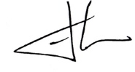 | 5 December 2023
Author 3 | Dedi Rachmadi | 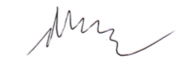 | 6 December 2023

